

**CG2111A Engineering Principle and Practice 2**

**AY 21/22 Sem 2**

**Design Report**

**TEAM:B01-6B**

| **Name** | **Student Number** | **Sub-Team** | **Role** |
| --- | --- | --- | --- |
| **Ang Jia Le Marcus** | **A0235025R** | **B01-6B-2** | **Hardware , Software** |
| **Anvitha Rajaram** | **A0223393H** | **B01-6B-2** | **Hardware, Report** |
| **Chao Yi-Ju** | **A0243361M** | **B01-6B-1** | **Hardware , Software** |
| **Cheah Hao Yi** | **A0239068W** | **B01-6B-2** | **Hardware , Software, Firmware** |
| **Yong Chin Han** | **A0234814H** | **B01-6B-1** | **Hardware , Software** |

**Table of Content**

**Section 1: Introduction** **3**

**Section 2: Review of State of the Art** **3**

2.1 ATLAS by Boston Dynamics 3

2.2 INACHUS by SINTEF 3

2.3 Learning from State of the Art 3

**Section 3: System Architecture** **4**

3.1 Hardware Architecture 4

3.2 Software Communication Protocol 4

**Section 4: Hardware Design** **5**

4.1 Final form of Alex 5

4.2 Non-standard hardware components: Ultrasonic sensors 6

**Section 5 Firmware Design** **6**

5.1 High level overview of algorithm on the Arduino Uno 6

5.2 Communication Protocol between Raspberry Pi and Arduino Uno 7

5.3 (Additional) Bare-metal Programming on the Arduino Uno 7

**Section 6 Software Design** **9**

6.1 High level overview of algorithm on Raspberry Pi 9

6.2 Noteworthy Software implementation 10

**Section 7 Lesson Learnt - Conclusion** **11**

7.1 Lesson 1 - Identifying faulty hardware connections 11

7.2 Lesson 2 - Being flexible around the unfamiliar software frameworks/ Open source programmes 11

7.3 Mistake 1 - Lack of synchronisation of work between team members 12

7.4 Mistake 2 - Inadequate software configuration of visualisation programme (Rviz) 12

**References** **13**

**Appendix A: Code on Arduino Uno** **14**

**Appendix B: Code on Raspberry Pi** **20**

**Appendix C: Code on the Laptop (Control Centre)** **25**

**Appendix D: Arduino Pin Configuration** **28**

# **Section 1:** Introduction

For this project, a robotic vehicle, Alex, will be built with search and rescue functionalities to navigate a novel simulated environment. Alex will be able to relay information about its surroundings to a human controller, who will control the movement of Alex remotely via wireless connections.

Alex would navigate in the transverse plane, through various enclosed spaces and ultimately park at a designated parking spot. Furthermore, Alex will be able to overcome uneven floor surfaces such as a hump during its navigation.

# **Section 2: Review of State of the Art**

This section highlights two state of the art search and rescue robots, namely ATLAS and INACHUS, and also describes their system functionalities, their hardware and software components, as well as their strengths and weaknesses.

## **2.1 ATLAS by Boston Dynamics**

* ATLAS was created to eventually participate in search and rescue operations.
* It is an electrically powered humanoid robot that can operate both indoors and outdoors. It has self-balancing capability and can sense obstacles through the use of sensors, stereo cameras and LiDAR technology. It can be operated via teleoperation as well as traverse difficult terrain and complete simple tasks like opening a door or climbing up a ladder. This is achieved through the use of hydraulic joints.
* ATLAS’s strengths lay in the fact that it is humanoid and thus can potentially perform more complex tasks than a non-humanoid robot. It is also able to recover to some extent should it fall or meet an obstacle. However, its large size makes it cumbersome and thus not suited to navigate small spaces where victims may be trapped.

## 

## **2.2 INACHUS by SINTEF**

* INACHUS’s primary purpose is to assist Urban Search and Rescue (USAR) teams in finding victims in disaster zones.
* It is shaped like a train or snake and is remotely controlled from a rugged tablet PC. INACHUS has two video cameras with lights attached for rescuers to get a clearer view of rubble that they cannot reach. It also has an infrared camera to detect survivors in the rubble and an electronic chemical sensor to help detect survivors through the composition of gases in the air. Two-way communication is also enabled so that survivors can communicate with rescuers.
* The strength of INACHUS is that it has many functionalities that enable rescuers many options in finding victims and providing immediate assistance to them. However, the slightly large size may mean it cannot reach very tight spaces. Furthermore, the need for power cables limits the range of INACHUS’s operation.

## **2.3 Learning from State of the Art**

* In both examples, the large size of the bot prevents it from entering small spaces.  
  To overcome this issue, Alex is designed with its components attached within its chassis to maximise compactness. Furthermore, to reduce reliance on cables to power the robot as in INACHUS, the RPi is used to allow for wireless remote control.

# Section 3: System Architecture

## **3.1 Hardware Architecture**

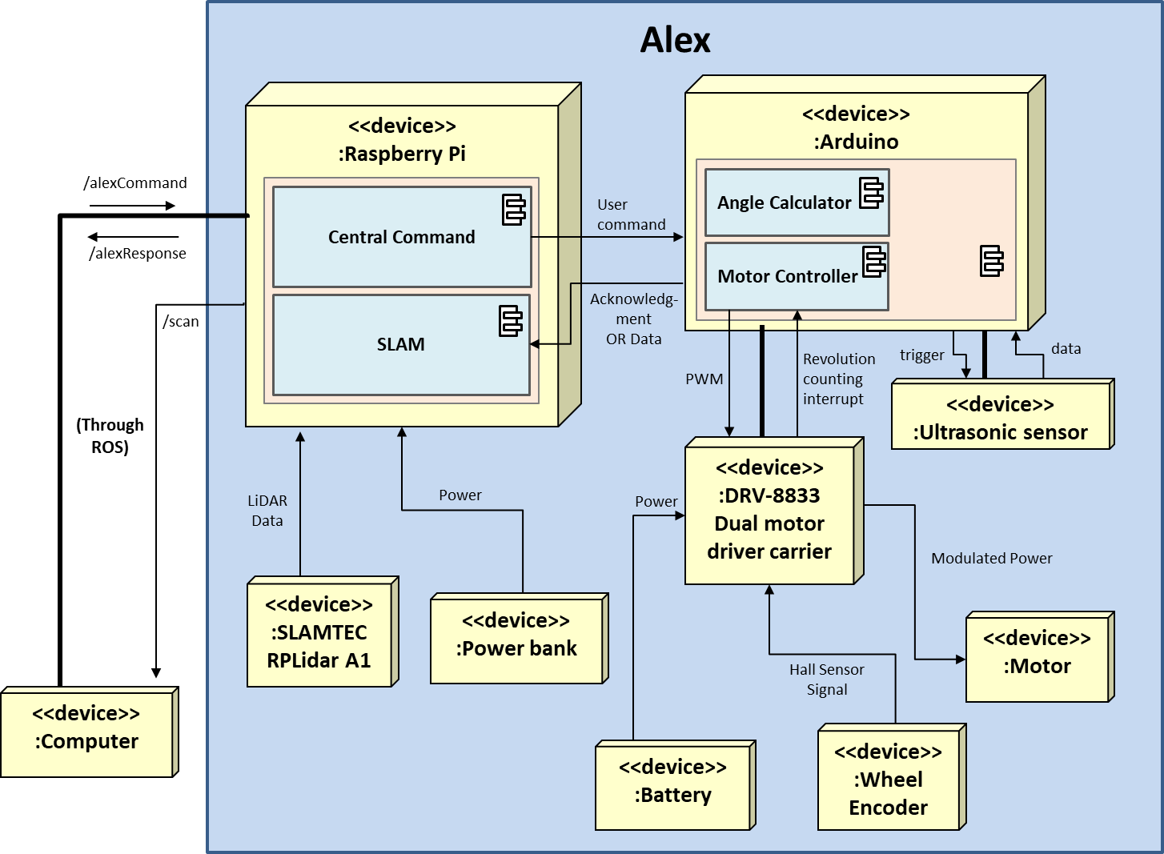

Fig. 1: System Model of Alex

## **3.2 Software Communication Protocol**

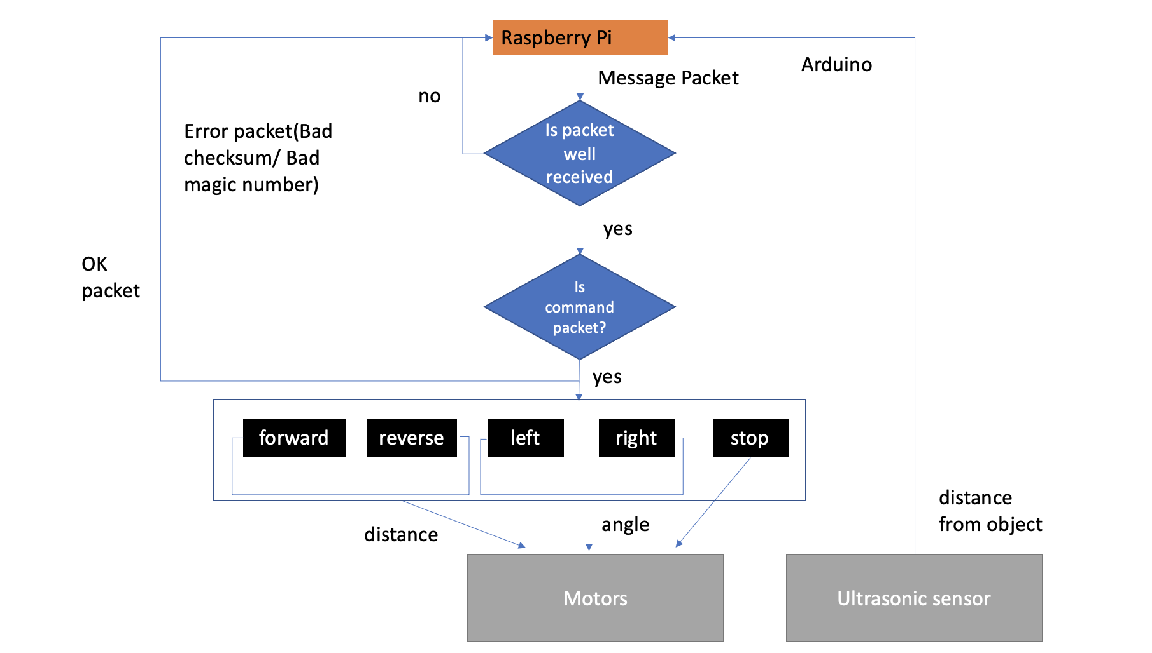

Fig. 2: Software Communication Flowchart

# 

# Section 4: Hardware Design

# 

This section shall focus on the hardware and overall system design of Alex.

## **4.1 Final form of Alex**

The following portrays the final form of Alex from different points of view.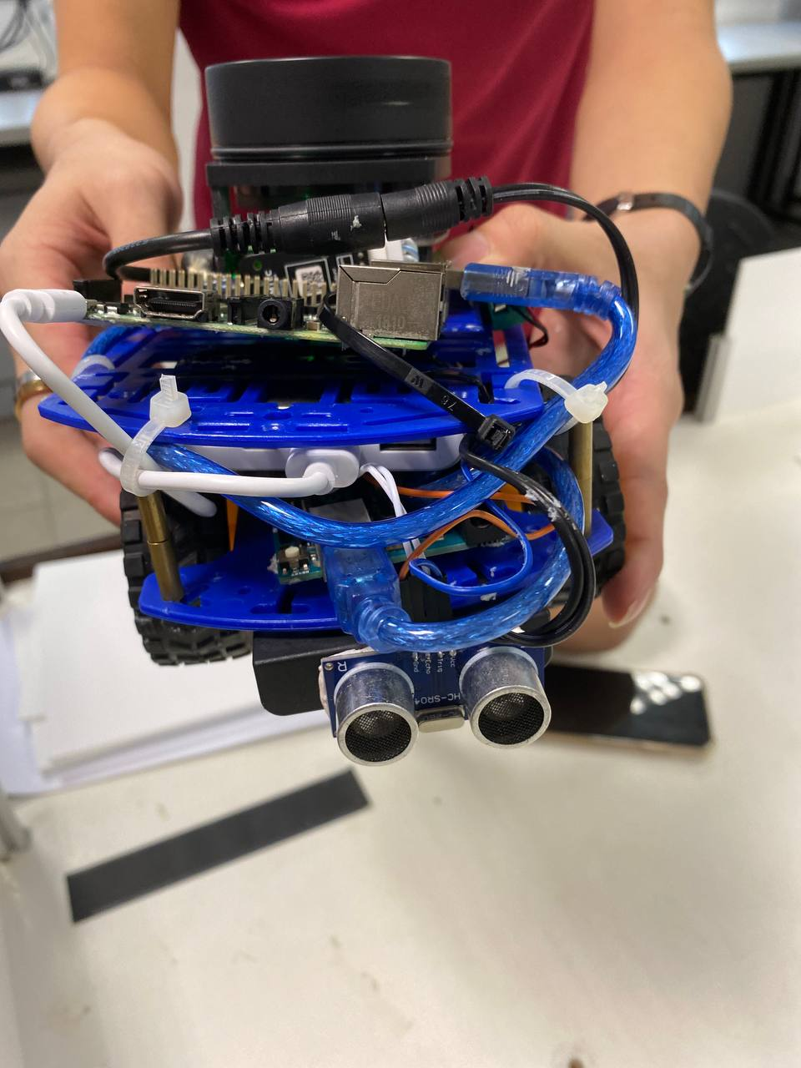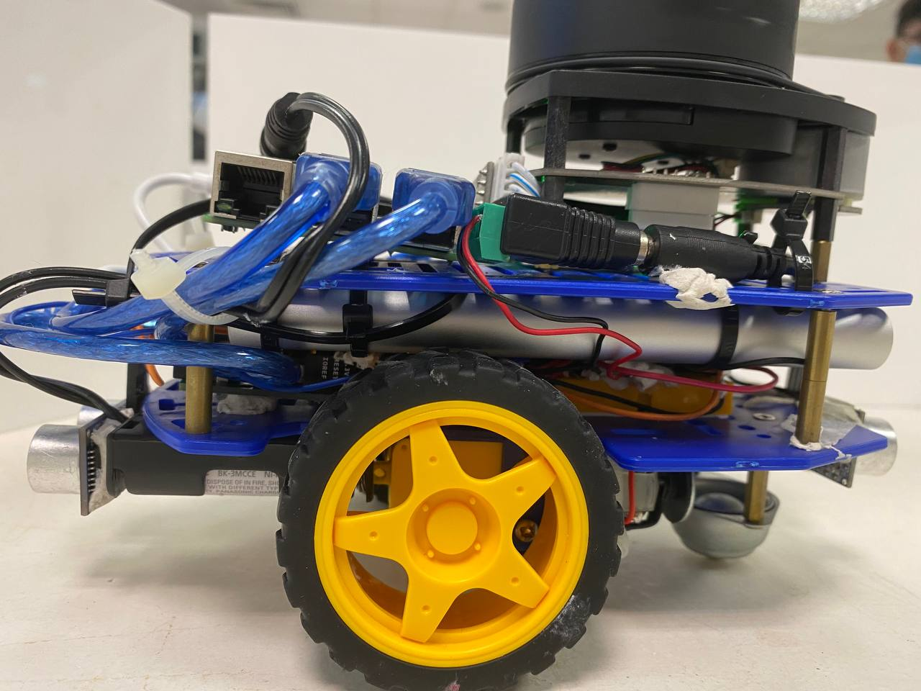

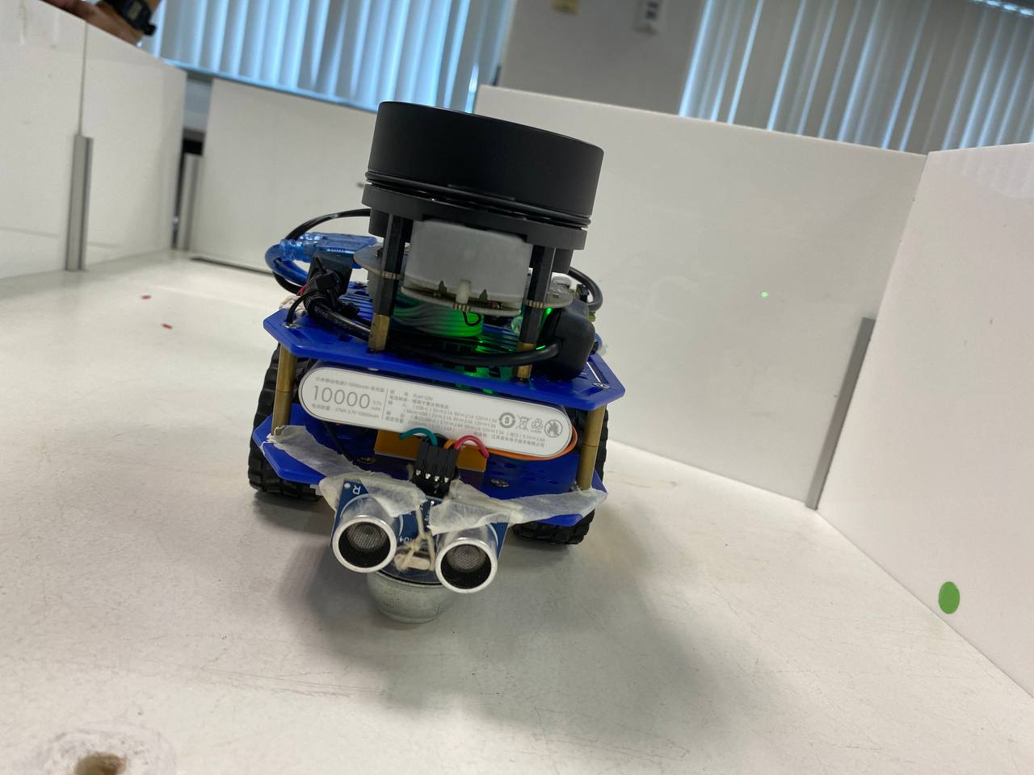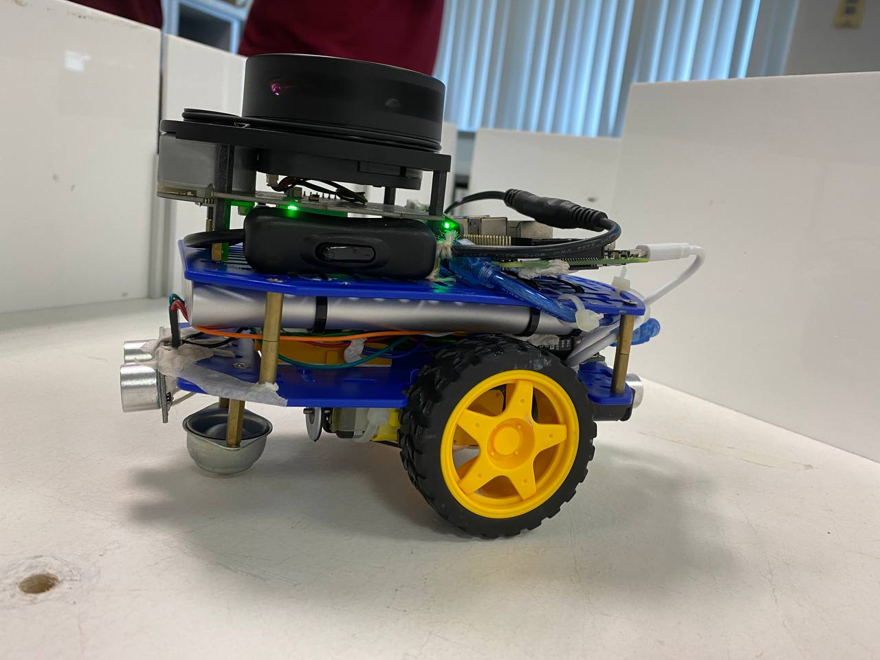

Fig.3: Front, Left, Back, Right of Alex (Clockwise from Top-Left)

Furthermore, the following exhibits the internal and external hardware components of Alex.

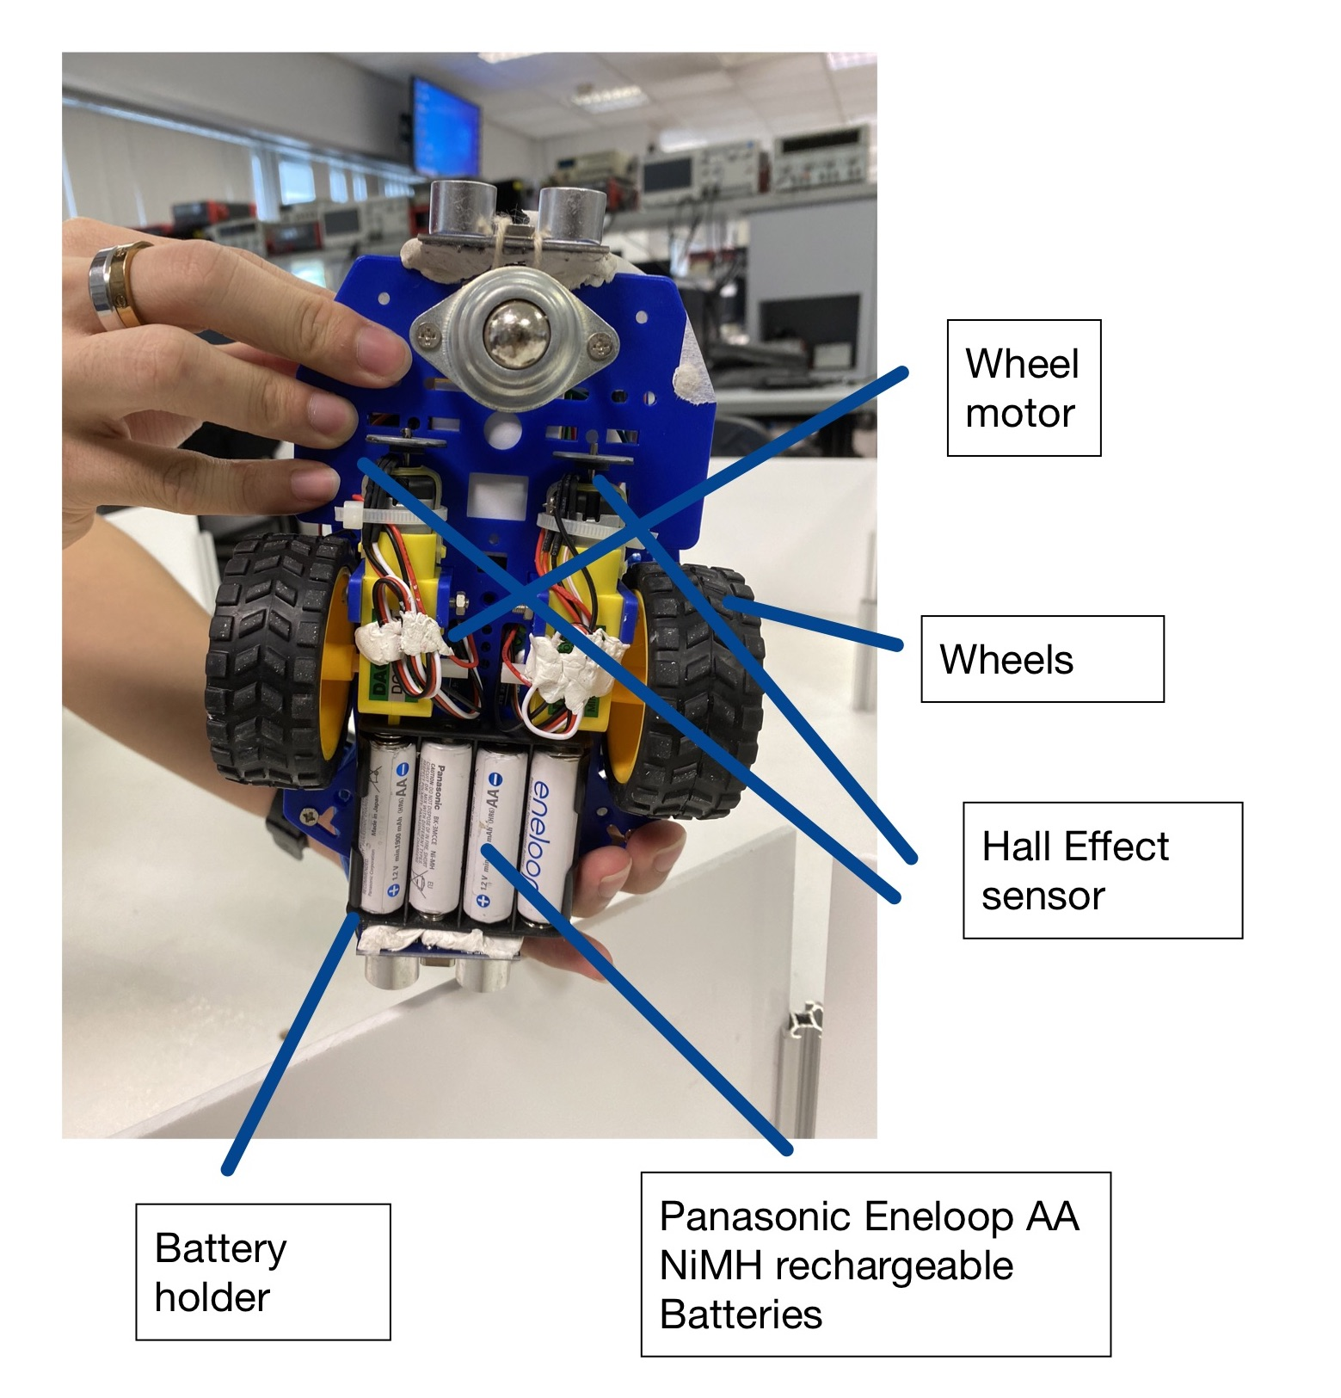

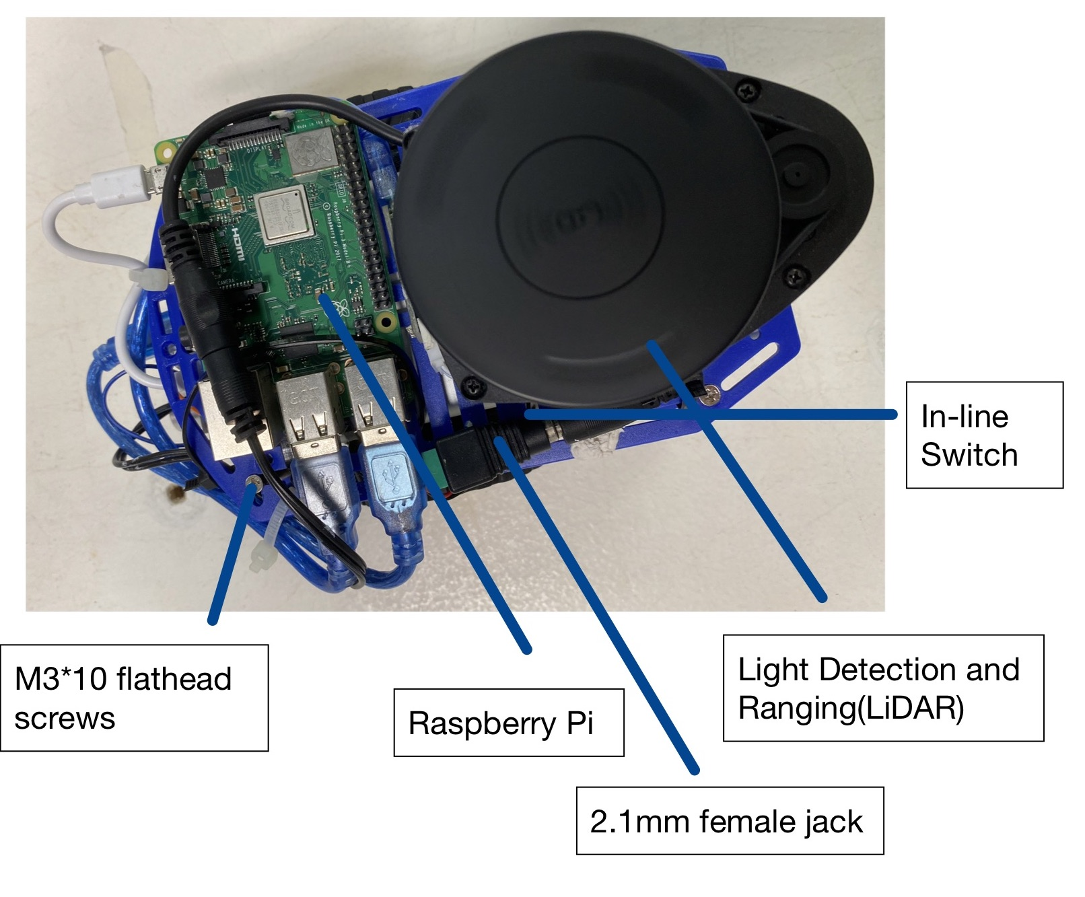

Fig.4: Top & Bottom of Alex (Left - Top; Right - Bottom)

## 

## 

## 

## 

Fig. 5: Internal Circuitry of Alex (Refer to Appendix D for clarity)

## **4.2 Non-standard hardware components: Ultrasonic sensors**

Two ultrasonic sensors are mounted at the front and rear of Alex respectively (refer to Fig. 3 for reference) to gauge the front and rear distance of Alex from potential obstacles. The purpose is to enable the operator to navigate through tight corners by gauging detected distances. The pin configurations for both ultrasonic sensors are as follows:

* Pin 11 (PB3): Both Front and Rear ultrasonic sensor Trigger Pin
* Pin 7 (PD7): Rear ultrasonic sensor Echo Pin
* Pin 12 (PB4): Front ultrasonic sensor Echo Pin
* 5V: Both Front and Rear ultrasonic sensor VCC Pin
* GND: Both Front and Rear ultrasonic sensor GND Pin

(Refer to Appendix D-2)

# Section 5 Firmware Design

## 5.1 High level overview of algorithm on the Arduino Uno

1. Setup and Initialization

* The Arduino will first write the corresponding bits onto the required registers

1. Continuous checks for command packets and reading of ultrasonic distance

* The Arduino would continuously checks for incoming command packet from the Raspberry Pi

1. Moving Alex

* If the Arduino received a movement command, it would update internal variables such as LeftTurnTicks to keep track of its movement

## 5.2 Communication Protocol between Raspberry Pi and Arduino Uno

1. Receiving information packet

* The Arduino receives the command packet from Raspberry Pi and checks for the validity of the packet
* If the packet is valid, the Arduino returns an acknowledgement packet back to the Raspberry Pi.

1. Executing commands

* If a command for movement is received, the arduino would read the command parameters (power/speed/angle) and update its internal variable accordingly.

1. Packaging and sending information back to the Raspberry Pi

* The Arduino retrieves data (from 2 ultrasonic sensors) encoding the distance of the obstacle right in front and behind Alex and sends it to the Raspberry Pi.

## 5.3 (Additional) Bare-metal Programming on the Arduino Uno

BARE METAL IMPLEMENTATION

1. Wheel Movements

* Set up external interrupt pins INT0 and INT1for falling edge trigger. The interrupts facilitate the tracking of wheel movements
* Enable pull up resistors to get the correct reading of the Hall Effect Sensors (Wheel Encoders)
* Set up Timer 0 and Timer 1 for PWM signals, pins used are OC0A, OC0B, OC1A, OC1B
* Change the duty cycle for the specific pin according to the movement required

1. Communications

* Setup USART for serial communication, asynchronous mode is used. Information obtained by the sensors will be sent back to Raspberry Pi for checking conditions
* Baud rate 9600, 8 bits, non parity, 1 stop bit
* Read the serial port and return the character when available. In addition, return TRUE if the character is valid.
* Write to the serial port

1. Ultrasonic Sensor ( Refer to Appendix A)

* Hardware implementation.
* Front ultrasonic sensor Trigger Pin connected to Arduino Pin 11. Echo Pin connected to Arduino Pin 12 (PB4) .
* Rear ultrasonic sensor Trigger Pin connected to Arduino Pin 11. Echo Pin connected to Arduino Pin 7 (PD7) .
* Software implementation in bare-metal.
* Both ultrasonic sensors would be concurrently triggered via Arduino Pin 11 which had been configured to output a PWM signal with a logic HIGH output lasting 0.32mS.
* The ultrasonic sensor would start transmitting a sonic burst after the Trigger Pin receives a signal of HIGH for at least 10uS.
* The echo pin would be set to HIGH automatically after the transmission of the sonic burst and would be set to LOW after the return of the sonic burst received by the sensor.
* The duration of the echo pin in the HIGH state would be the duration it takes for sound to travel from the ultrasonic sensor , reflected from a surface and back to the sensor.
* Time measurements are taken via the micros() function to keep track of the duration of the first reading(when the sonic burst has been transmitted) and second reading (when the sonic burst is received or time out).
* The ultrasonic distance values would be checked for errors (due to time out). Time out values would have distances set to zero by default.
* Distance values could be calculated by the formula: ( Second_reading - First_reading )* 0.034 /2 , which returns the distance in cm.
* Pin 11 timer configuration - Connected to Trigger Pins of both ultrasonic sensors.
* Timer 2 (on PB3) configured as a 62500Hz (7.8%) PWM which outputs HIGH for 0.32mS.
* PWM period: 4.08mS.

* Interrupt configuration and distance measurement.
* PCINT4 (on pin 12) via the PCINT0_vect triggered every time the front ultrasonic sensor’s Echo Pin signal toggles.
* PCINT23 (on Pin 7) via the PCINT2_vect triggered every time the rear ultrasonic sensor’s Echo Pin signal toggles.
* Transmission of ultrasonic distance values to the Raspberry Pi.
* The current ultrasonic distance values would be packaged within statusPacket before transmission to the Raspberry Pi.
* Error values (distance set to ‘0’ by default) would be printed as “0” on the operator’s screen to prompt the operator to re-attempt to request for the updated ultrasonic distance values.

# 

# Section 6 Software Design

## 

## **6.1 High level overview of algorithm on Raspberry Pi**

1. Initialisation of Robot Operating System (ROS) node and topics

* The ROSCore is initialised on one instance of the bash terminal on the laptop, serving as the ROS Master and the command control.
* The Raspberry Pi (on Alex) serves as the ROS slave, with the ROS Master IP address set to that of the laptop.
* ROS communication nodes, publisher and subscriber are initialised on both the laptop and Raspberry Pi (on Alex) to establish the communication between the devices over a common internet hotspot connection.
* Upon starting the command script on Alex, the Raspberry Pi sends a hello packet to the Arduino microcontroller.
* The Arduino upon verification of the hello packet returns an acknowledgement packet to the Raspberry Pi.
* Concurrently, the connection to the Lidar is initialised and the Lidar starts scanning the surroundings and transmitting environmental data back to the laptop through the ROS topic */scan.*
* The user interface that displays the mapping visualisation (RVIZ), messages from the ROS topic */alexResponse* and terminal for the user to input commands are initialised.

1. Telecommunication of movement command

* User inputs one of the four-movement commands (W - forward, A - turn left, X - reverse, D - turn right) into the terminal on the laptop as a string.
* The laptop publishes the message onto the ROS topic */alexCommand.*
* The Raspberry Pi, being subscribed to the same */alexCommand* topic, reads the message.

1. Acknowledgement of movement command

* The Raspberry Pi processes the message received, by taking only the first character of the string message (this is to defend against the user accidentally spamming the movement command).
* The Raspberry Pi looks up the corresponding command, packages the command with pre-calibrated navigation parameters (power, speed, angle) into a command packet and sends it to the Arduino.
* The Raspberry Pi publishes a short description of the movement to be carried out on the ROS topic /alexResponse, which serves as an acknowledgement to the user and reaffirms the user about the movement command received.
* The laptop, which is subscribed to the ROS topic /alexResponse, reads and displays the message from Alex onto the user interface on the terminal.

1. Response of environmental data

* The RPLidar sends the Lidar data to the Raspberry Pi, which is then published onto the /scan topic.
* The laptop reads the lidar data from the /scan topic and feeds it into the visualisation program, rviz.
* The rviz program will display a map of the environment, the real-time data recorded and the location of Alex on the map

1. Tuning of navigation parameters, if necessary

* If the user notices an anomaly with regards to the manoeuvring of Alex, for instance, if Alex encounters an obstacle, or Alex gets stuck at certain parts of the map, the user can send in commands to increase or decrease the navigation parameters (power, speed, angle)
* The user can also manually request the navigation parameters, distance data (from the ultrasonic sensor on the Arduino) and the state of the internal variable of the Arduino (LeftTicks, RightTicks, Forward distance, Reverse Distance)
* The distance data from the ultrasonic sensor can be cross-validated against the SLAM visualisation to better understand the environment around Alex.

1. Repeat until the task is completed

* Once Alex has mapped out the whole environment, Alex will navigate to a specific spot on the map to be parked
* Once Alex navigates to the last room on the map, the program on Alex can be exited remotely when the user enters the exit command (Q)
* The TMUX programme can be exited normally on the laptop and returns to the bash terminal.

# 

## 6.2 Noteworthy Software implementation

* The program to receive user command and send command to Arduino is written and compiled under the ROS framework using catkin_make
* The initialization of ROS programmes and user interface are automated through bash scripts on the laptop and Raspberry Pi. (Refer to Appendix B and Appendix C)
* The user interface is built using TMUX, an open-source terminal multiplexer for Linux. It allows multiple terminal sessions to be accessed simultaneously in a single window. (Refer to item B-11 and C-5 under the appendix)
* The Roslaunch file for Rplidar on the Raspberry Pi was edited to disable the map visualisation which would be too computationally taxing for a Pi.
* The Roslaunch file for the Rplidar is transferred to the laptop, only enabling the Rviz programme for the laptop to read, compute and display a localization map.

# 

# 

# Section 7 Lesson Learnt - Conclusion

## 7.1 Lesson 1 - Identifying faulty hardware connections

The team had acquired the ability to execute a systematic hardware debugging process during the identification and resolution of multiple unknown hardware faults, as well as having a flexible mindset during rectification of hardware problems.

In an event of unknown hardware fault in the context of this project, often when motors remain unresponsive while power was on, the team assumed that the fault was due to connection issues like loose or incorrect pin configurations, and thus we repeatedly checked such configurations while the actual issue was the poor connection between the batteries and battery holder springs, leading to a multitude of time lost. The proper debugging process should start from checking the presence of loose wires, examine voltage path from circuit schematics then lastly, connection configurations.

The poor connection between the batteries and battery holder springs was a constant problem for the team. Due to this issue, the team had to unknowingly change batteries and the battery holder multiple times, which was time consuming. However, the team had managed to find an easy solution for this problem. The solution simply requires the battery holder springs to be pulled evenly, gently yet sufficiently to allow the springs to regain their elasticity and contact range, enabling proper contact when batteries are inserted in the holder. This technique will be very relevant in any similar projects.

## 7.2 Lesson 2 - Being flexible around the unfamiliar software frameworks/ Open source programmes

The team has learned the skill of researching for information through internet forums to implement new functionalities and dealing with unexpected errors throughout the project.

For the project, the team decided to dual boot one of our laptops and implement the Robot Operating System (ROS) framework for the communication between the Pi and laptop, both of which are new to everyone in the team.

While working with the Ubuntu operating system, we encountered errors such as Wifi-connection non-detectable and faulty monitor display. Countless hours were spent on forums such as Stackoverflow, askUbuntu and various thirdParty forums to search for possible mitigations despite often incomplete information available. The team navigated the problems through trial and error, trying out many methods until we achieved the desired outcome. Needless to say, there are instances where some attempts worsened what was available, when we were trying to fix the faulty display on external monitors, some configurations were accidentally overwritten, causing the operating system to not be able to boot normally. In the end, we need to reboot a new instance of Ubuntu onto the laptop again.

For the ROS framework, we learned to be creative when finding workarounds while working within the restrictions of the framework. For example, when we are unable to include the header files into the main control programme under the framework, we decided to duplicate all the code in the header files into the main programme for it to work. Furthermore, when we first could not find a way to declare the ROS publisher and subscriber object as global variables (to receive and publish messages anywhere), we instead created global boolean and string variables that allowed us to publish messages within the scope of the ROS objects (we later realised that there are certain workarounds for ROS object declaration on forums as well).

We had the opportunity to explore beyond what is taught and integrate certain open source softwares to automate certain processes throughout the whole project. For example, bash scripts were written to start the initialization of all the necessary programs easily (only the custom defined “start” command needed on the terminal). We also explore the usage of TMUX to provide an intuitive interface for users to control and monitor various processes simultaneously rather than opening up multiple instances of the terminal.

## 7.3 Mistake 1 - Lack of synchronisation of work between team members

While specific tasks were allocated to each member, each member worked in isolation on their own area of expertise without continuous update of each other's progress. While there were checkpoints for the team to converge and discuss the overall progress, each member is specialised to the extent where other members may not have all the prerequisite knowledge to validate each other’s progress. This caused difficulty when trying to integrate all the code onto the Arduino and Raspberry Pi.

Although a private github repository was created for this project, not all members are fully familiar with github, limiting the use of the repository for version control.

## 7.4 Mistake 2 - Inadequate software configuration of visualisation programme (Rviz)

Due to insufficient configuration due to limited knowledge of the specific configurations required, Alex could not map its surroundings accurately during the trial demo. The pointer for Alex is offset by some amount on the visualisation and the exact location of Alex could not be determined accurately, causing it to bump into the wall 25 times during the trial.

This resulted in our trial demo being a missed opportunity to rigorously test Alex’s capabilities in a simulated environment. While we managed to rectify the configuration after the trial demo and tested Alex on other simulated environments, nonetheless we did not have a second chance to work under the timed and stressful environment to navigate, map the environment and draw out the map.

# 

# **References**

Marafioti, G., page, A. G. M. E. P., & Name. (2019, January 25). *Snake-like Robots   
Assisting Urban Search and rescue teams (inachus project)*. #SINTEFblog. Retrieved April 8, 2022, from https://blog.sintef.com/digital-en/inachus-project-robot-search-rescue/

Wevolver.com. (n.d.). Retrieved April 8, 2022, from https://www.wevolver.com/wevolver.staff/atlas.robot#:~:text=Atlas%20is%20designed%20to%20operate,electrically%20powered%20and%20hydraulically%20actuated

# Appendix A: Code on Arduino Uno

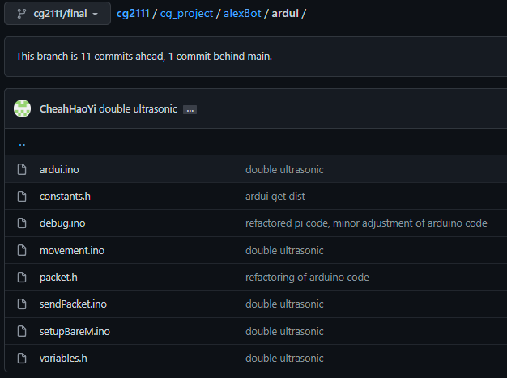

A-1: Organisation of functions and variables declaration into separate files for easy reference

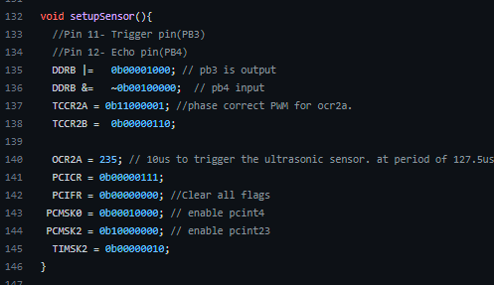

A-2: Setting up the 2 ultrasonic sensor

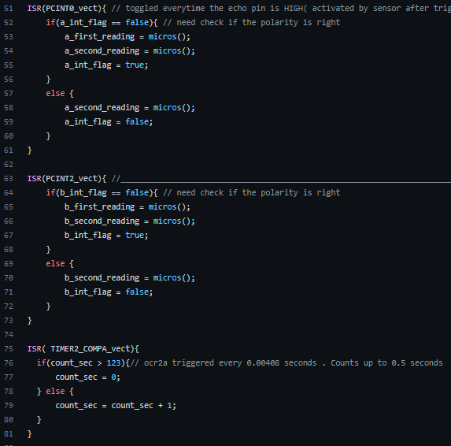

A-3: Interrupt functions for ultrasonic sensors

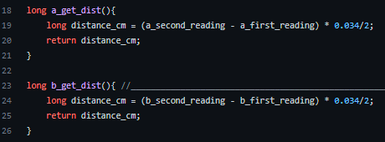

A-4: Functions to get distance from the ultrasonic sensor

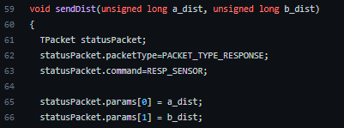

A-5: function to send distance data back to Raspberry Pi

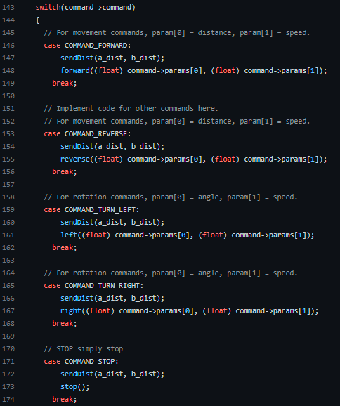

A-6: functions to execute movement and transmit distance data to Raspberry Pi

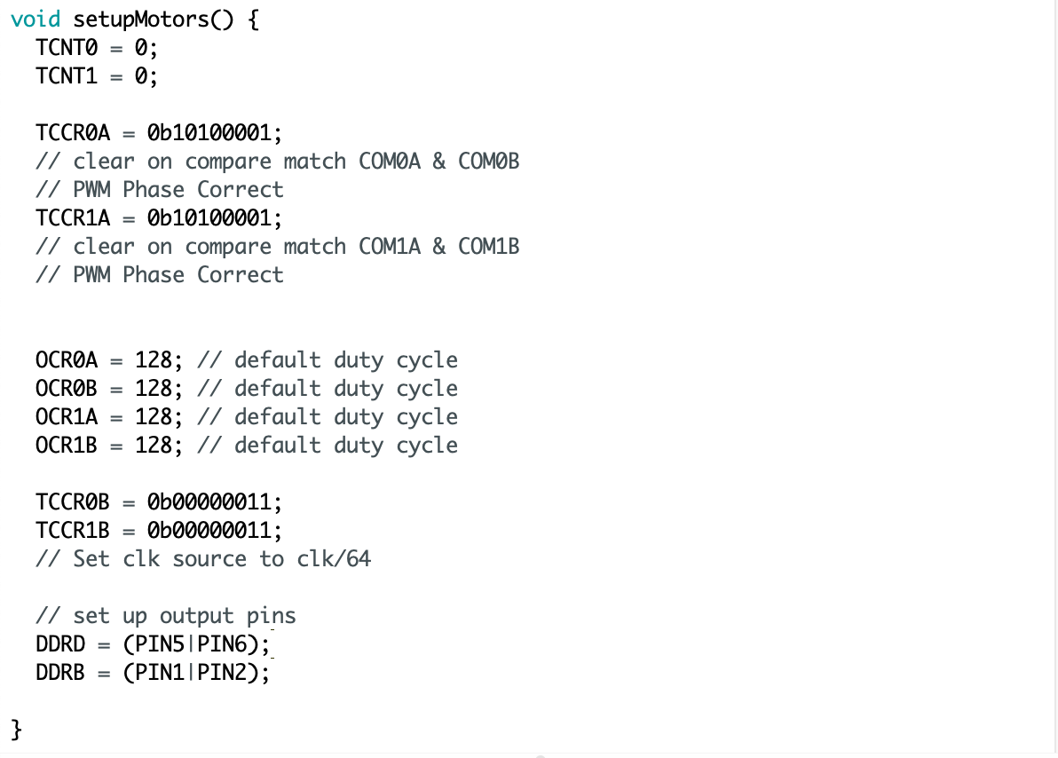A-7 setupMotors(): setting up PWM signals and output pins

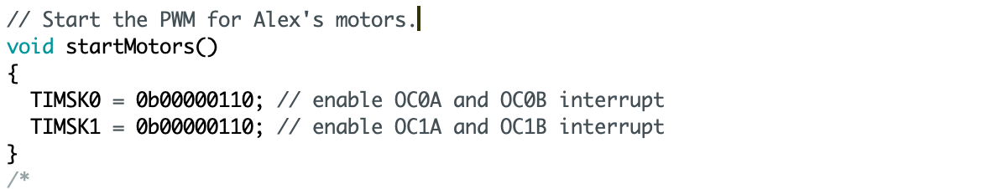

A-8 startMotors(): enabling timers’ interrupt

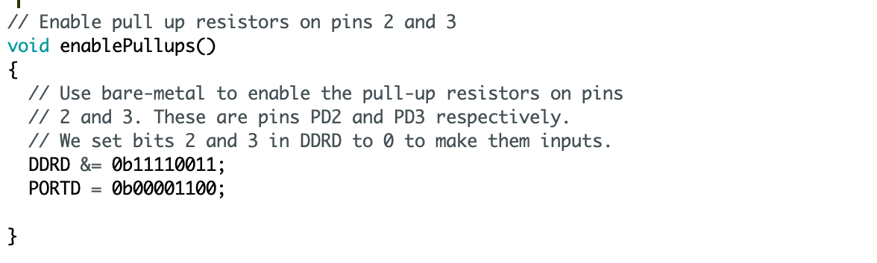

A-9 enablePullups(): enabling pullup resistors

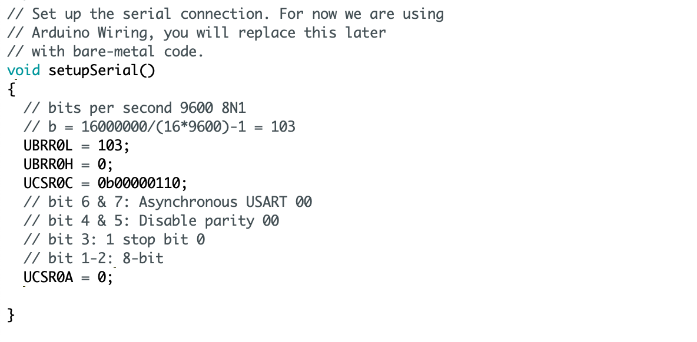

A-10 setupSerial(): Setting up USART communication

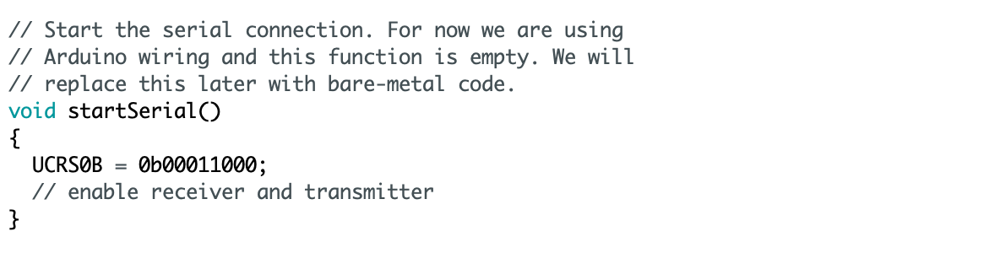

A-11 startSerial(): enabling the receiver and transmitter

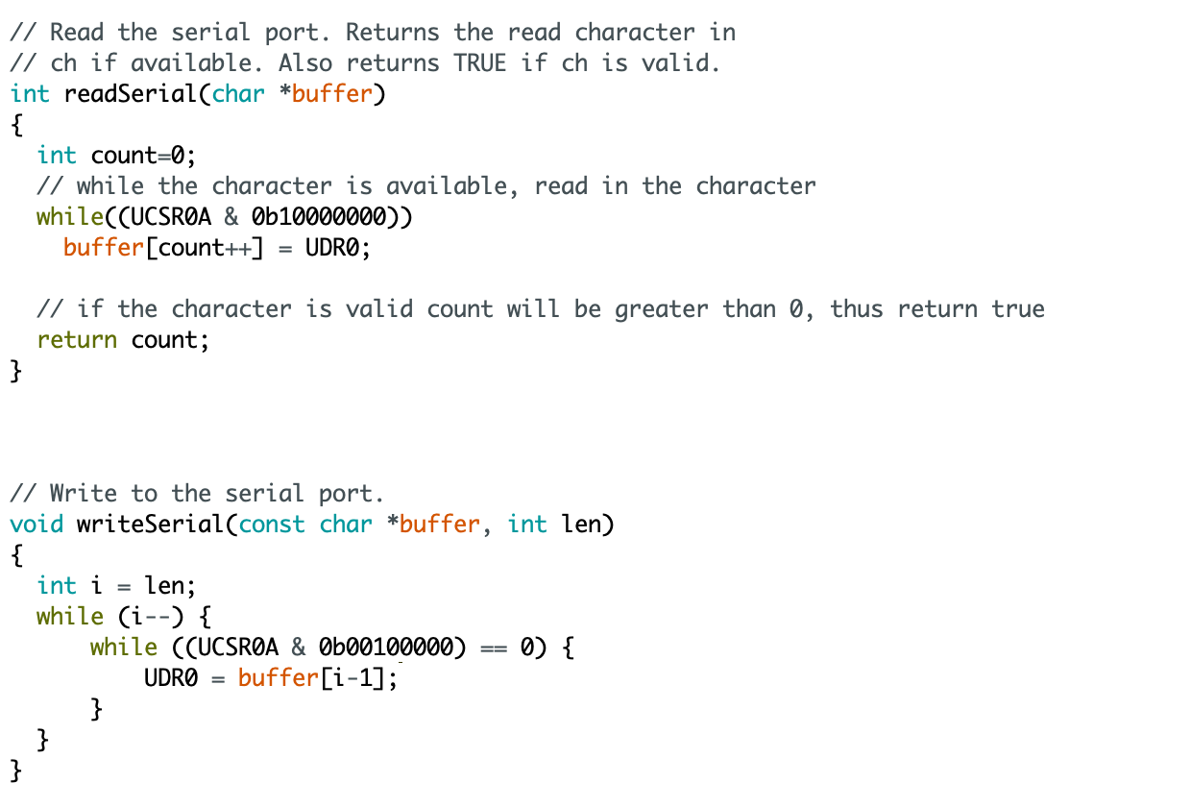

A-12 readSerial() & writeSerial()

# **Appendix B: Code on Raspberry Pi**

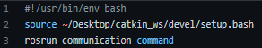

B-1 command.sh: script to start the ROS slave node on the Raspberry Pi

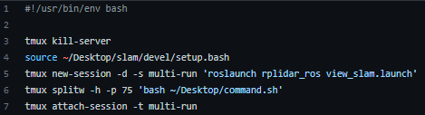

B-2 start.sh: script to initialise the tmux interface for transmitting Rplidar data and receiving user command from the laptop

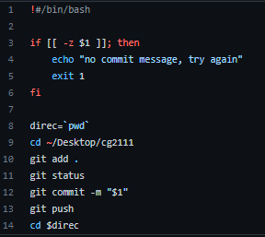

B-3 push.sh: script to automate the pushing of code to github

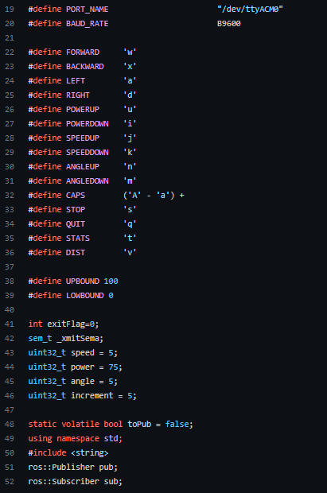

B-4 ros_control.cpp: declaration of movement control keys and calibrated navigation parameters

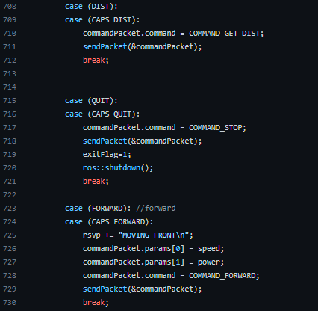

B-5: Execution of getting distance, quitting and forward command, other movement functions are similarly defined

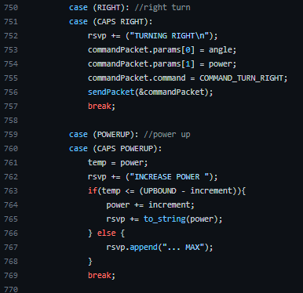

B-6: Execution of turning and changing navigation parameters, other turning and tuning functions are similarly defined

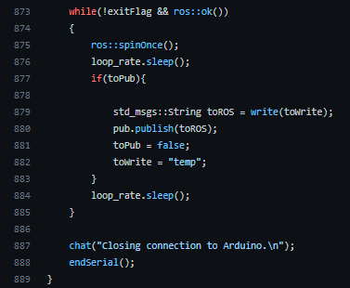

B-7: main() code flow in ROS_control.cpp

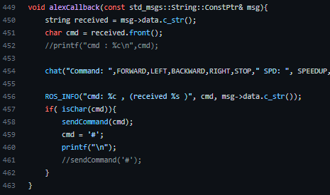

B-8: callback function that define the routine when the Raspberry Pi receive user command from the Laptop

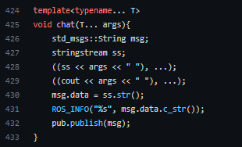

B-9: wrapper function for printf() to print string to terminal and publish to the ros topic at the same time, using a variadic function compliant with c++17 standard

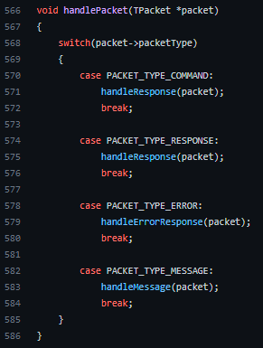

B-10: communication protocol between Pi and Arduino

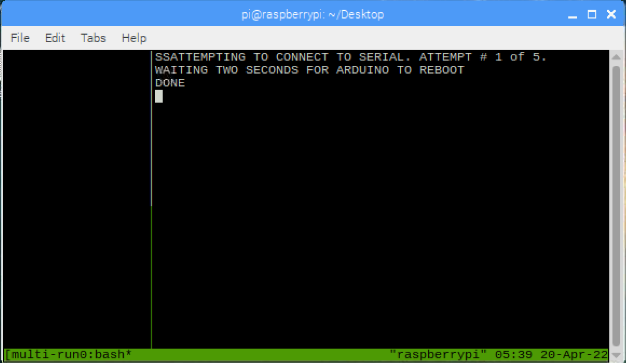

B-11: user interface on the terminal when start.sh is executed

# Appendix C: Code on the Laptop (Control Centre)

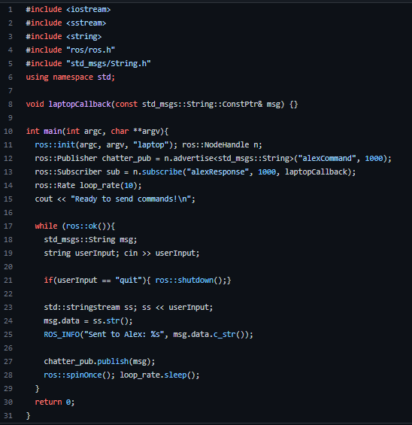

C-1 userInput.Cpp: program for user to input and transmit commands from the laptop to the Raspberry Pi

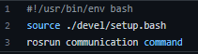

C-2 command.sh: script to start userInput.cpp program

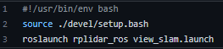

C-3 mapping.sh: script to start the rviz program for map visualisation

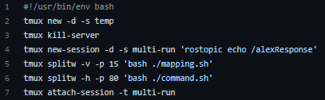

C-4 start.sh: script to automate the initialization of tmux interface

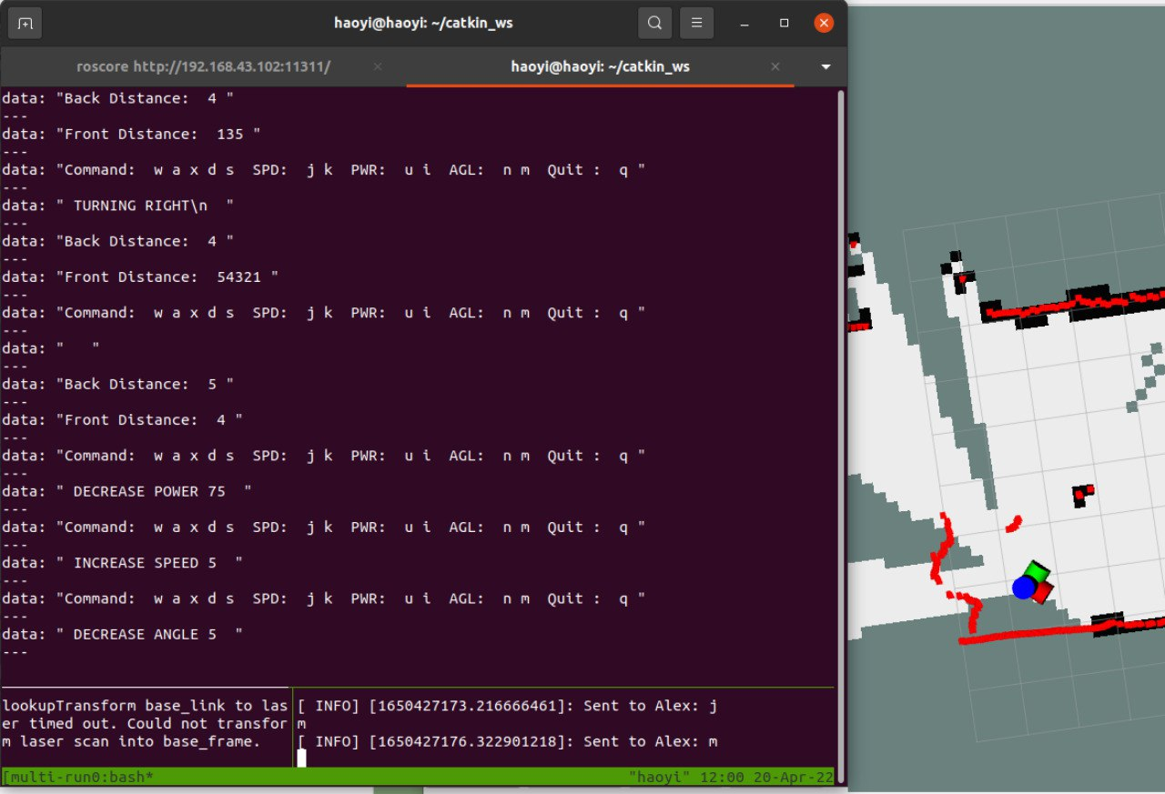

C-5 User interface during the “Search and Rescue” Operation

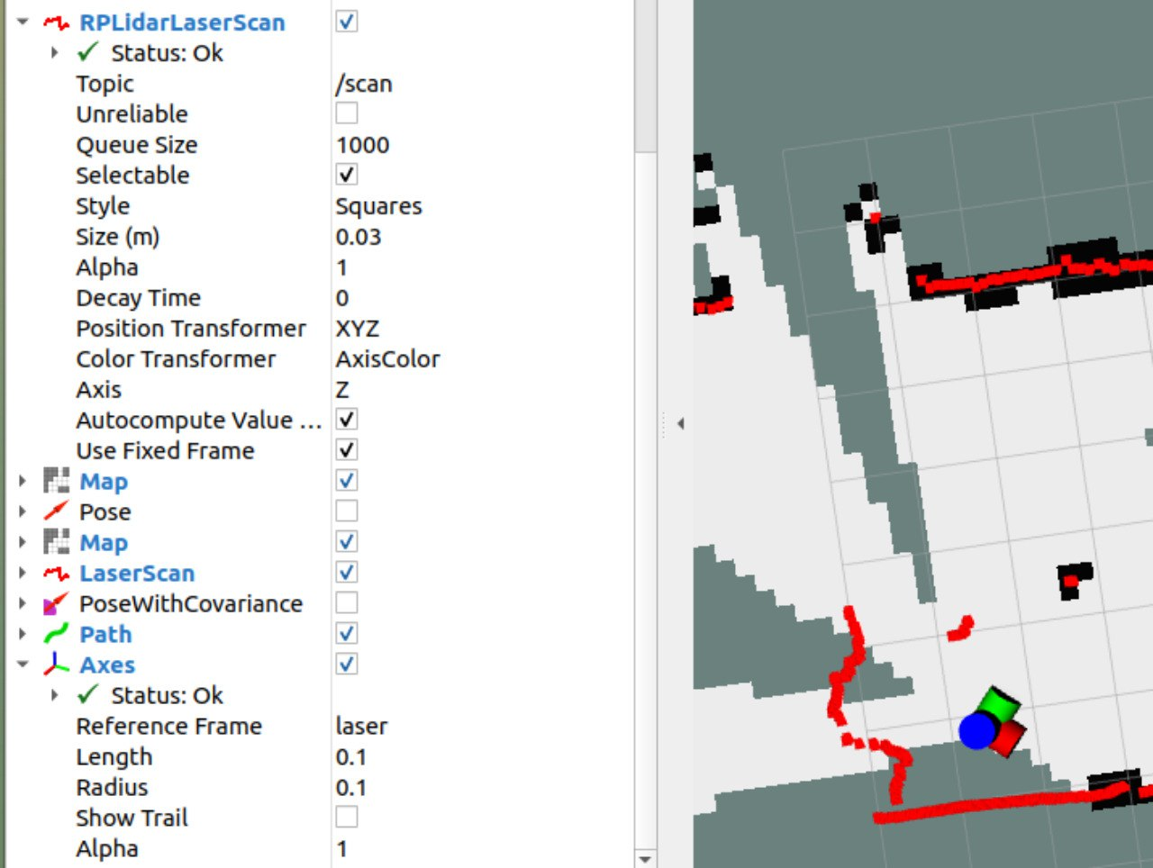

C-6: Some of the configuration used for Rviz

# Appendix D: Arduino Pin Configuration

*D-1: Motor Pin Configuration* 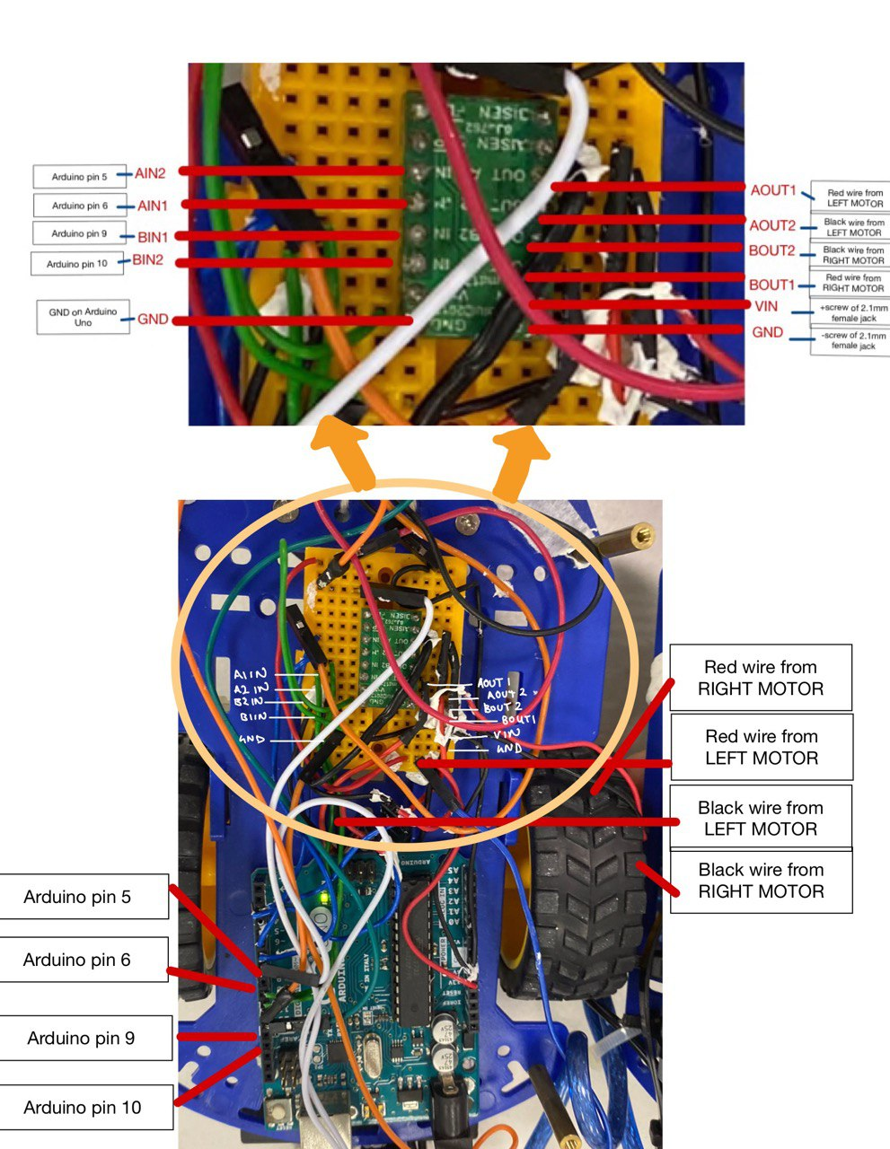

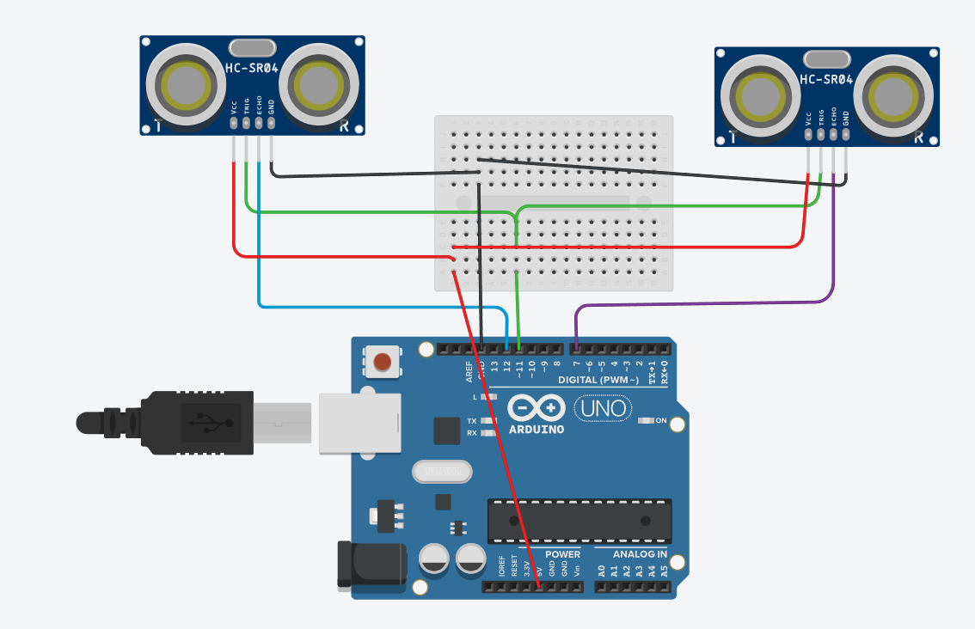

D-2: *Ultrasonic sensors pin configurations simulated for clarity*